Name__________________________________________________

**Measuring Ingredients**

**The three tools used to measuring ingredients are:**

|  |  |  |
| --- | --- | --- |
| 1. | 2. | 3. |
| http://t1.gstatic.com/images?q=tbn:ANd9GcTgID4JsAqzYsofbPJ_bzaMCz3-TSgcVXwvfbbAfzCVGeBL-KBMzw:www.apronstringsstore.com/Images/6818555621986435329_1.jpg | http://t2.gstatic.com/images?q=tbn:ANd9GcQfT_LgMHe7cJkDL-Ms7LbFL-PJVIGAK13j-mTnoUodr6e7i-x3zw:st.houzz.com/simgs/80a188bb03429017_4-1193/contemporary-measuring-cups-and-spoons.jpg | http://t1.gstatic.com/images?q=tbn:ANd9GcRtaMh38e1Eu2axr6mBB-ArybE9rDuffhtplC88MgyJmPmaKuPk2g:s7d9.scene7.com/is/image/BedBathandBeyond/6526614120815p%3F%24478%24 |

**TECHNIQUES FOR MEASURING:**

When measuring **liquids or syrups** it is best to use a *liquid measuring cup.*

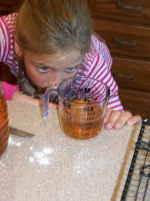Keep your liquid measuring cup on a ________________ surface and pour your liquid into the liquid measuring cup. Look at the measurements at eye level, bend over. Do not hold the liquid measuring cup up to your eye. This will not be an accurate measurement.

Examples of liquids or syrups measured in a liquid measuring cup:

1.________________________ 3._______________________ 2.________________________ 4.________________________

When measuring **dry or solid** ingredients it is best to use *dry measuring cups.*

They commonly come in a set of 4. They measure 1 cup, ½ cup, 1/3 cup and ¼ cup.

Examples of dry or solid ingredients measured in a dry measuring cup:

1._________________________ 3.__________________ 5._____________________

2._________________________ 4.__________________ 6._____________________

To measure **flour or sugar**: scoop the ingredient into the dry measuring cup until the ingredients overflow. Do not pack or pat down the ingredients. After the measuring cup is full,

level it with a straight edge. A straight edge could be a __________________________,

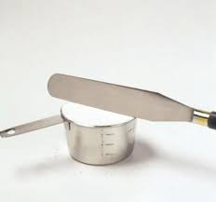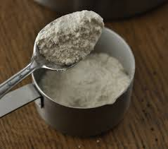__________________________ or _________________________. Do not use a kitchen knife because it has a curved edge.

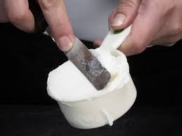

To measure **peanut butter or shortening** (CRISCO) : scoop the ingredients into a _______________ measuring cup. Pack the ingredients down so there is no air stuck in the middle. Then level with a straight edge.

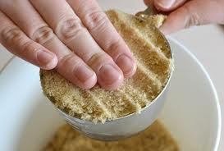

To measure **brown sugar**: add brown sugar to dry measuring cup until it overflows, push down the brown sugar as hard as you can to pack it in. Level with

a straight edge.

To measure **small amounts of liquid and dry ingredients** use *measuring spoons*.

Measuring spoons often come in a set of four, 1 tablespoon, 1 ___________________,

½ teaspoon & ¼ teaspoon. Examples of ingredients that you would only measure small amounts of:

1.____________________________ 3.________________________

2.____________________________ 4.________________________

When measuring small amounts of ingredients it is best to measure over a sink or garbage can.

Do not measure over your ingredient bowl in the event too much poor’s out.

For a **heaping spoon** measure until no more ingredients can possibly fit into the spoon. Do not level.

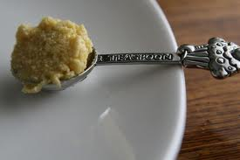

If a recipe doesn’t indicate a “heaping” spoon you must level it. Pour your ingredients into your **measuring spoon** until it is slightly over the edge (do this over the sink or garbage can). Then level with a straight edge.